**PRACTICAL NO:-2**

**a. Create a simple application to demonstrate the concepts boxing and unboxing.**

**CODE:-**

using System;

using System.Collections.Generic;

using System.Linq;

using System.Web;

using System.Web.UI;

using System.Web.UI.WebControls;

namespace security

{

public partial class boxing : System.Web.UI.Page

{

protected void Page_Load(object sender, EventArgs e)

{

}

protected void Button1_Click(object sender, EventArgs e)

{

string a = TextBox1.Text;

Object ob = Convert.ToDecimal( a);

decimal b = (decimal)ob;

Label1.Text = "The given value is" + b.ToString();

}

}

}

**OUTPUT:-**

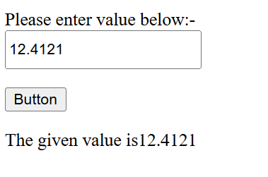

**b. Create a simple application to perform addition and subtraction using delegate.**

**CODE:-**

using System;

using System.Collections.Generic;

using System.Linq;

using System.Web;

using System.Web.UI;

using System.Web.UI.WebControls;

namespace db1

{

public partial class _delegate : System.Web.UI.Page

{

protected void Page_Load(object sender, EventArgs e)

{

myclass cls = new myclass(12, 13);

string s =Convert.ToString( cls.calc("ADDITION"));

Response.Write("Addition is"+s);

string s1 = Convert.ToString(cls.calc("SUBSTRACTION"));

Response.Write("<br>Substraction is" + s1);

string s2 = Convert.ToString(cls.calc("MULTIPLICATION"));

Response.Write("<br>Substraction is" + s2);

string s3 = Convert.ToString(cls.calc("DIVISION"));

Response.Write("<br>Division is" + s3);

}

}

class myclass

{

float a, b;

public myclass(float num1, float num2)

{

a = num1;

b = num2;

}

public delegate float operation();

public float add()

{

return a + b;

}

public float sub()

{

return a - b;

}

public float mul()

{

return a * b;

}

public float div()

{

return a / b;

}

public float calc(String a)

{

operation op;

if (a == "ADDITION")

{

op = add;

}

else if (a == "SUBSTRACTION")

{

op = sub;

}

else if (a == "MULTIPLICATION")

{

op = mul;

}

else if (a == "DIVISION")

{

op = div;

}

else

{

return 0; //else is required otherwise not able to send value.

}

return op();

}

}

}

OUTPUT:-

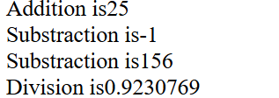

**c. Create a simple application to demonstrate use of the concepts of interfaces.**

**CODE:-**

using System;

using System.Collections.Generic;

using System.Linq;

using System.Web;

using System.Web.UI;

using System.Web.UI.WebControls;

namespace new1

{

public partial class WebForm1 : System.Web.UI.Page

{

protected void Page_Load(object sender, EventArgs e)

{

areafind fd = new areafind();

int a=fd.print_circle(2);

int b=fd.print_rectangle(5);

string b1 = Convert.ToString(b);

string a1 = Convert.ToString(a);

Response.Write("Rectangle square "+b1.ToString());

Response.Write("<br>Circle diameter is " + a1.ToString());

}

}

public interface printl

{

int print_circle(int a);

int print_rectangle(int a);

};

public class areafind : printl

{

public int print_circle(int radius)

{

return radius*2;

}

public int print_rectangle(int side)

{

return ((side*side));

}

}

}

**OUTPUT:-**

